**Chapter 4**

**Design**

1. **Use Case**

A use case diagram at its simplest is a representation of a user's interaction with the system that shows the relationship between the user and the different [use cases](https://en.wikipedia.org/wiki/Use_case) in which the user is involved. The use cases are represented by either circles or ellipses.

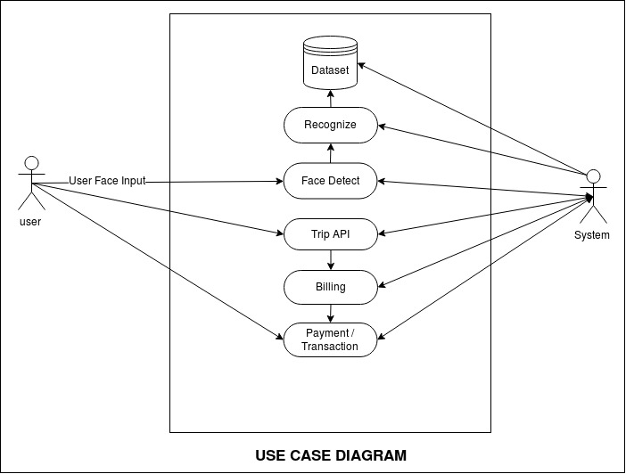

Fig 4.1: Use Case

Use case diagrams are valuable for visualizing the functional requirements of a system that will translate into design choices and development priorities. They also help identify any internal or external factors that may influence the system and should be taken into consideration. They provide a good high level analysis from outside the system. Use case diagrams specify how the system interacts with actors without worrying about the details of how that functionality is implemented.

1. **Data Flow Diagram**

A data flow diagram (DFD) is a graphical representation of the "flow" of data through an information system, modelling its process aspects. A DFD is often used as a preliminary step to create an overview of the system without going into great detail, which can later be elaborated.

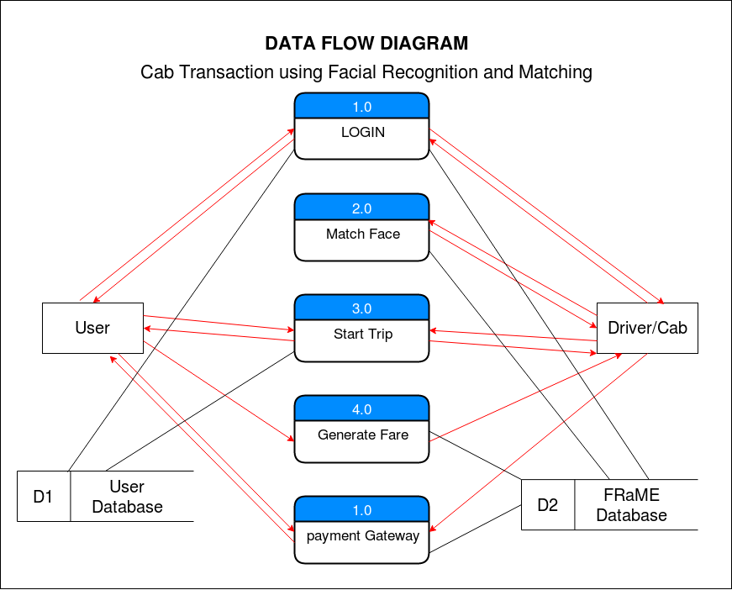

Fig 4.2: Data Flow Diagram

Data flow diagrams can be divided into logical and physical. The logical data flow diagram describes flow of data through a system to perform certain functionality of a business. The physical data flow diagram describes the implementation of the logical data flow.

1. **Sequence Diagram**

A sequence diagram simply depicts interaction between objects in a sequential order i.e. the order in which these interactions take place. We can also use the terms event diagram**s** or event scenarios to refer to a sequence diagram. Sequence diagrams describe how and in what order the objects in a system function.

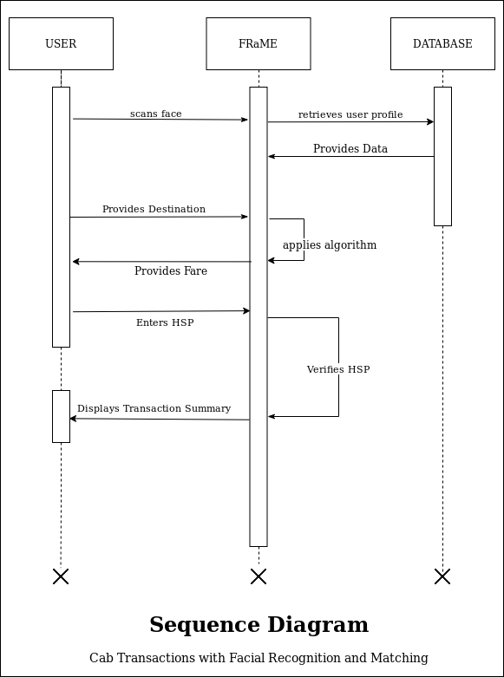

Fig 4.3: Sequence Diagram

A sequence diagram shows, as parallel vertical lines (lifelines), different processes or objects that live simultaneously, and, as horizontal arrows, the messages exchanged between them, in the order in which they occur. This allows the specification of simple runtime scenarios in a graphical manner.

1. **Activity Diagram**

Activity diagram is a flow chart to represent the flow form one activity to another activity. The activity can be described as an operation of the system. The control flow is drawn from one operation to another.

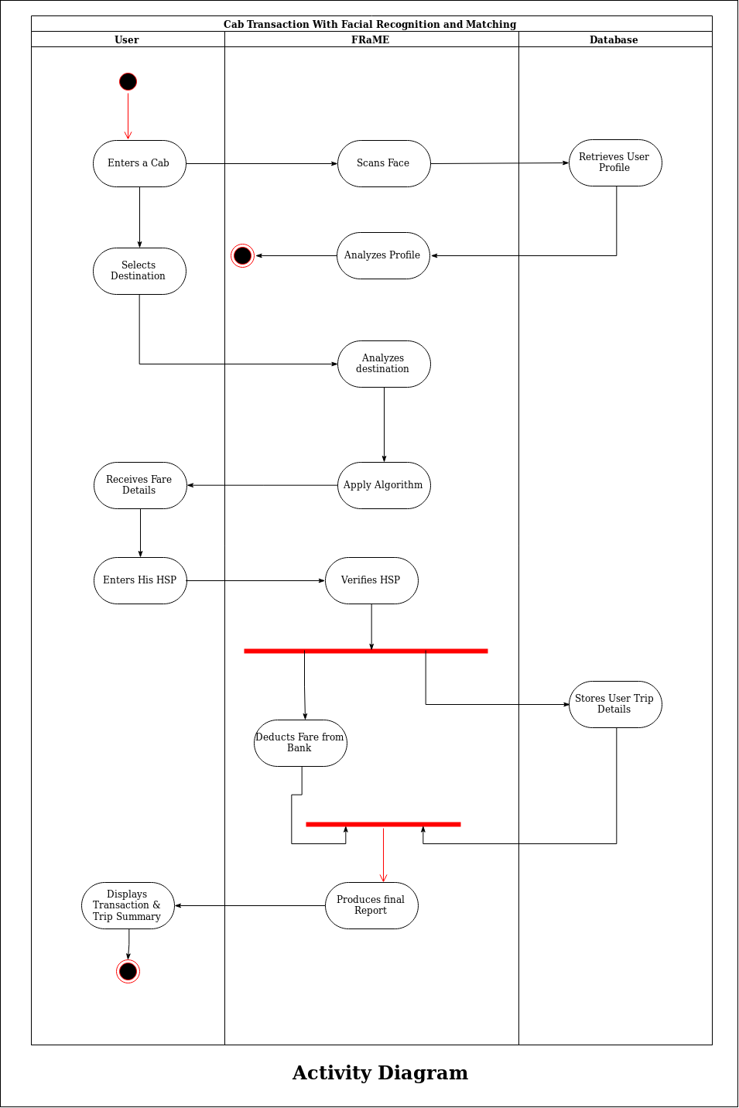

Fig 4.4: Activity Diagram

This flow can be sequential, branched, or concurrent. Activity diagrams deal with all type of flow control by using different elements such as fork, join, etc.